Cybersecurity Incident Report: Network Traffic Analysis

Scenario
A number of users reported that they were unable to access the website yummyrecipesforme.com. Instead of loading the webpage, they received an error message: “destination port unreachable.”
As a security analyst, you are asked to investigate the issue. You used a network packet analyzer (tcpdump) to capture and review the traffic while attempting to access the website. Based on the captured network logs, analyze the traffic and determine the root cause of the issue.
Summary of the problem found in the DNS and ICMP traffic log
- A network issue was observed while trying to access the website yummyrecipesforme.com. The system attempted to contact a DNS server using UDP protocol to resolve the domain name. However, instead of receiving a valid response, ICMP error messages were returned indicating 'udp port 53 unreachable'.
This shows that communication with the DNS server failed. Since port 53 is used for DNS services, it suggests that the DNS server was either down or not responding properly.
The traffic analysis using tcpdump confirmed repeated UDP requests to the DNS server and ICMP error responses. This clearly indicates a DNS-related issue affecting website access.
Analysis and Possible Cause
- The issue was first noticed at around 1:24 PM when users reported that they were unable to access the website and received a 'destination port unreachable' error.
After investigation, packet capture analysis showed that DNS requests sent over UDP were not getting valid responses. Instead, ICMP errors confirmed that port 53 was unreachable.
The security team is currently investigating the issue to restore access. The next steps include checking if the DNS server is down or if a firewall is blocking traffic on port 53.
A possible cause could be a DNS server failure due to misconfiguration or a Denial of Service (DoS) attack. Another possibility is incorrect firewall settings blocking DNS traffic.
Figure 1: DNS request followed by ICMP error (port 53 unreachable)
This output shows that DNS queries are sent successfully, but the server responds with ICMP errors indicating that port 53 is unreachable, confirming a DNS service failure.
Figure 2: Repeated DNS failures indicating persistent issue
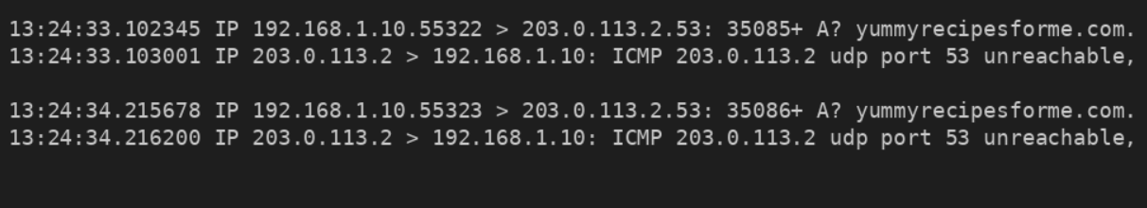
The output shows that DNS queries are sent successfully, but the server responds with ICMP errors indicating that port 53 is unreachable, confirming a DNS service failure

Flow Diagram
User System
(Browser)
|
| 1. DNS Request (UDP 53)
v
DNS Server
|
| 2. ICMP Response – Port 53 Unreachable
|
v
Resolution Failed
Website Not Loaded

